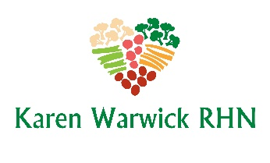
COMPLIANT CHOW MEIN WITH KONJAC NOODLES
This recipe is oil free and uses versatile konjac noodles in place of regular egg noodles making this a low-calorie meal.
Ingredients: Makes 2 big servings
- Up to ¾ cup low sodium soup stock for ‘frying’
- ½ a medium onion, sliced
- ¼ small head of cabbage, finely sliced
- 1 large handful of bean sprouts
- 2-3 shitake mushrooms, sliced
- A little grated carrot for color (optional)
- 1 Tbs. lite tamari (optional)
- Konjac noodles, traditional style, rinsed well
- 1 green onion sliced
- 1 tsp. raw sesame seeds (optional)
Method:
- Heat a wok or large skillet on medium high.
- Add onion and ¼ cup soup stock and fast fry for 1 minute.
- Add cabbage, bean sprouts, and mushrooms and more liquid as needed and fast fry for 5 minutes until vegetables are soft.
- Add carrot and tamari (if using) and mix through.
Okay….at this point remove half the vegetables to a glass storage container if you are not eating both servings now.
Finishing:
- Add the rinsed noodles to the vegetable mixture and heat through stirring and adding liquid if needed.
- Once heated through, serve in a bowl topped with sliced green onion and sesame seeds if using.
Note: You can heat through refrigerated leftovers and noodles in the microwave for about 2 minutes and top with the fresh green onion and seeds if using.

