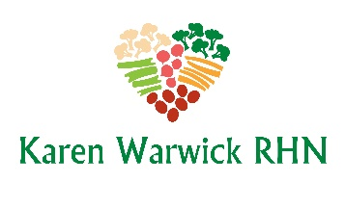
COMPLIANT LENTIL MUSHROOM LOAF
I have altered this recipe from the book Staying Alive! Cookbook for Cancer Free Living. This loaf is absolutely delicious and was a big hit at Christmas. It would also serve well for Easter dinner and family Sunday dinners. Makes 6-10 servings
Ingredients:
- ¾ cup brown lentils
- 3 cups of water for boiling
- 2 Tbs. apple cider vinegar
- A little water for ‘frying’
- 1 cup finely minced onion
- 5 large garlic cloves, minced
- ½ cup brown mushrooms, finely ground
- 1 Tbs. salt-free seasoning (cremini, shitake, etc.)
- 2 cups fresh spinach, finely sliced
- 1 tsp. seeded or Dijon mustard
- Fresh ground black pepper to taste
- ½ cup rolled oats
Method:
- Rinse lentils and put in a small pot. Add water, bring to a boil, lower heat to medium low and simmer, covered for 30 minutes until the lentils are mushy and soft. Drain the lentils and transfer to a medium sized mixing bowl, add the vinegar and mash well.
- While the lentils are cooking, prepare the onions, garlic, mushrooms in a mini food processor and finely slice the spinach.
- Heat the water in a non-stick pan over medium heat. Sauté the onions for about five minutes until translucent. Add the garlic, mushrooms, spinach and seasonings and sauté for another 5-10 minutes until all the vegetables are tender. Preheat oven to 350.
- Add the vegetable mixture to the mashed lentils and add the rolled oats. Mix well and spoon into a silicon loaf pan. Press down gently with a spatula.
- Bake at 350 F for about 40 minutes. Let cool for 5-10 minutes before removing from the loaf pan. Turn out onto a serving plate.
- Slice and serve with gravy.

