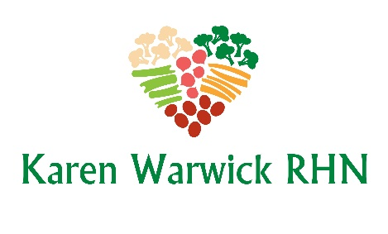
HOLIDAY FAT FREE GRAVY
Adapted from Chuck Underwood’s recipe
An easy, rich vegan gravy that takes minutes to prepare. Super low in fat and sodium so you can slather your meal in it. Enjoy! Makes 4 cups.
Ingredients
- ¼ cup Tapioca flour
- ¼ cup Nutritional yeast
- 2 tsps. onion powder
- 1 tsp. garlic powder
- 1 tsp. black pepper
- 4 cups vegetable broth (low-sodium)
- ¼ cup low sodium tamari
- 1 tsp. Dijon mustard
- 1 tsp. Vegan Worcestershire sauce
Method
- Put all the ingredients in a blender and blend until well combined.
- Pour mixture into a medium saucepan and place on medium-low heat.
- Whisk-stir the gravy until bubbly and thickened.
- Serve as you like. This gravy stores well in the fridge for 3-5 days in a glass jar.

