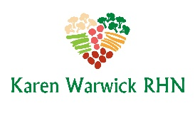
COMPLIANT BROCCOLI STIR FRY
This recipe makes about 8 cups so it is a super easy way to have your side dish of vegetables ready to go. It’s also a great way to get more vegetables into any bowl of stew or chili. This lowers the caloric density and fills you up with lots of fiber-rich vegetables.
Ingredients:
- ½ large onion, cut into cubes
- 2 garlic cloves, roughly chopped
- 1 head broccoli, cut into small florets and cut up stem
- 1 carrot, sliced
- 3 fresh shitake mushrooms, sliced
- 1 chili pepper, diced small
- ½ - ¾ cup low sodium vegetable broth (preferably organic)
- 2 large leaves Bok choy, chopped
- 2 green onions, thickly sliced
Method:
- In a wok or large skillet, heat a little vegetable broth on medium high.
- Add onion and garlic to the pan and cook quickly until the onion is soft.
- Add broccoli, carrot, mushrooms, chili and vegetable broth and stir.
- Cover with a lid and let cook for 5 minutes and then stir.
- Add Bok choy and green onions to the top of the broccoli mixture. Put the lid back on and steam for about 2 minutes until Bok choy wilts.
- Stir to mix and serve hot. Or let cool and store in the fridge in glass containers.

