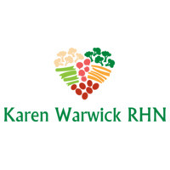
NICE CREAM
Here is the most delicious and nutritious version of ice cream. It has the benefit of no added sugar and lots of fiber which is great for anyone wanting to lose weight but needing something sweet. There is no guilt in eating a scoop or two after your meal with this decadent but compliant dessert.
When shopping ALWAYS buy bananas. When they get too ripe to enjoy them, peel and freeze them. They are one of basics for all compliant baking as they act as both a binder and a natural sweetener. And, of course, frozen they become part of the best and healthiest dessert ever!
There are a couple of ways of making this:
- If you have a YONANAS machine like I do, you simply alternate bananas and another frozen fruit through the device. The Pineapple Banana Version above made just shy of a liter using 2 bananas and about 2-3 cups of frozen pineapple.
- The other method is to use a good blender or NUTRIBULLET. In the blender, you will need to add about ¼ cup of some plant milk. To get the fruit at least starting to mix. You will probably need to stop the blender a few times to add a little more plant milk and break apart the big clumps with a butter knife to get the blades breaking down the fruit again.
After you have finished mixing it you can transfer it to a container that you can keep in the freezer. Use an ice cream scoop. If you don’t freeze it again, it will be more of a stiff milkshake consistency and you’ll end up eating much more than you should.
With the YONANA machine I can run it right into the freezer container and just mix with a spoon and flatten for an even flavour. Enjoy!

