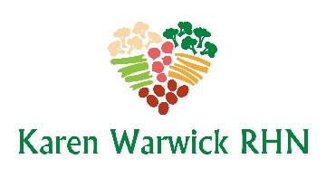
COMPLIANT CAESAR SALAD
By Cathy Fisher of StraightUpFood.com
I like this recipe when I want a fattening Caesar salad without the fat and salt. I have adjusted this recipe to be oil and fat free.
You can buy pre-washed romaine lettuce in packages of three. The dressing makes enough to dress three salads. And one can of chickpeas can be divided into three parts as well. I eat this giant salad over three consecutive days.
Ingredients for Salad (1 serving)
- 1 large head romaine lettuce, coarsely chopped*
- 1 red bell pepper, seeded and chopped
Ingredients for the Dressing (3 servings)
- ½ cup filtered water
- 1 can cooked white beans (navy or cannellini) Or 2 cups steamed cauliflower
- Juice of 1 lemon
- 2 Tbs. Dijon mustard
- 1 Tbs. raisins or 1 date, chopped
- 1 medium clove garlic, chopped
- 1 tsp. dried Italian seasoning
Method
- Place the lettuce and bell pepper into a large bowl.
- Put all dressing ingredients into a blender and blend until smooth.
- Pour one third of the dressing over the salad and mix well.
- Sprinkle with nutritional yeast. (optional)
- Add Compliant Caesar Chickpeas. (optional)
- Add freshly ground pepper to taste.
*Note: Using a plastic knife to cut the Romaine stops it from going brown. Or hand ripping the lettuce also can reduce oxidation. If you will be eating this salad over several days, prepare you lettuce this way, but store it separate from the dressing until you are ready to serve.

