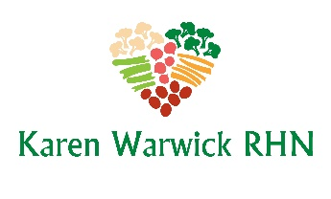
COMPLIANT GOLDEN YUM DRESSING
I have created this dressing with two versions. One is a standard dressing and the other is a creamy version.
Ingredients:
- 1/3 cup apple cider vinegar
- 1 cup purified water
- 2 Tbs. chia seeds
- 1/3 cup tamari
- 1-4 garlic cloves, minced
- 1/2 cup nutritional yeast flakes
Ingredient for creamy version:
- 2 cups steamed cauliflower or 1 cup Chef AJs Honey Mustard Dressing
Method:
​
- Combine the water and chia seeds in a blender for an hour. This will help the chia to set so the dressing will blend smooth.
Note: If you are making the creamy version, steam your cauliflower now and set aside to cool.
- Add the remaining ingredients to the chia seeds and water in the blender and blend until smooth.
- Store dressing in glass jars in the fridge. The basic version makes about 1⅔ cups. The creamy version makes 2⅔ cups of dressing.

