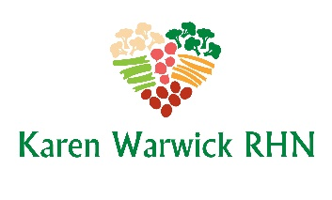
COMPLIANT PUMPKIN PUDDING
By Chef AJ
This recipe is great if you want that pumpkin pie taste but you have neither the time nor the energy to bother. It makes 4 big servings and it is ready to eat in 15 minutes. This recipe is super healthy with tons of fiber from the dates, pumpkin, chia seeds and banana. There is no sugar, salt or oil in this guilt-free recipe.
Ingredients
- 1 cup unsweetened plant milk
- ⅔ cup pitted dates, chopped
- ⅓ cup chia seeds
- 1 can pumpkin (not pie filling)
- 1 banana
- 1 Tbs. vanilla
- 1 Tbs. pumpkin pie spice
Method
- In a blender, but the plant milk, dates and chia seeds in to soak for at least 5 minutes to soft.
- Add pumpkin, banana, vanilla and pumpkin pie spice. Blend until smooth.
- Pour into 4 small bowls and cover. Chill in the fridge for several hours or overnight.
- Optional: Dust with cinnamon before serving.

