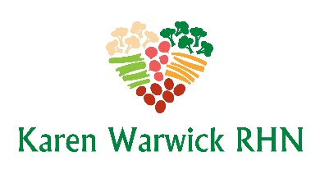
COMPLIANT RAW ZOODLE SALAD
This is a great salad for lunch or as a different kind of salad to take to a potluck.
Ingredients:
- 2 zucchinis
- 1 large tomato
- 6 soaked, sun-dried tomatoes
- ¼ - ½ cup water or tomato juice
- 2 cloves garlic
- 1 soaked date
- 2 Tbs. fresh basil
- Salt free seasoning and/or pepper to taste

Method:
- Soak the sun-dried tomatoes and date in the water/tomato juice for a couple of hours or even overnight.
- Spiralize the zucchini into noodles, or with a peeler into ribbons, and place in a large serving bowl. Tip: line the bowl with paper towel and let zucchini rest for 15 minutes to dispel excess water into the paper towel. Then discard paper towel.
- For the sauce, place the tomato, sun-dried tomatoes, water, garlic, date, basil and seasoning in a food processor/blender until smooth.
- To serve, place the zucchini noodles into a big bowl and pour the raw sauce over the top, just like you would for a bowl of pasta and toss to mix.

Tip: You can blanch the noodles in boiling water for two minutes so you can serve this dish hot in winter.

