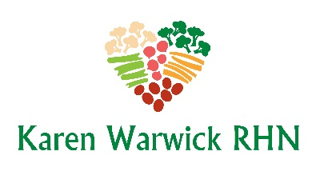
GREEK INSPIRED TABOULEH
The spices and herbs in this tabouleh satisfy that craving for that high fat Greek salad that we all love so much. This paired with the COMPLIANT GREEK DRESSING, will give you a new flavour profile for your breakfast salad.
For a change you can substitute rice for quinoa and serve it as a side dish or with roasted or steamed vegetables.
Greek Inspired Quinoa Ingredients:
- 1 cup rinsed quinoa
- 2 cups of filtered water
- 2 tsps. dried oregano
- 1 tsp. dried thyme
- 1 tsp. onion powder
- 1 tsp. garlic powder
- ½ tsp. dried marjoram
- ½ tsp. dried mint
Method
- Rinse the quinoa and add it to a medium sized pot.
- Add the filtered water to the pot.
- Add all the herbs and powders directly to the pot and stir.
- Bring to a boil, cover with a lid and reduce heat to minimum. Cook for 20 minutes and no peaking.
- After 20 minutes, remove from heat and let cool with or without lid.
Greek Inspired Tabouleh Ingredients:
- Cooked and cooled quinoa
- 1 can of chickpeas, rinsed
- ¼ red onion, diced
- 1 tomato, deseeded and diced
- ½ cup fresh parsley, chopped
- Juice of 2 lemons
Method
- In a large bowl (with lid), combine the quinoa, chickpeas, red onion, tomato, fresh parsley and lemon juice.
- Mix until thoroughly combined. Cover with a lid and store in the fridge. This keeps for about a week.

