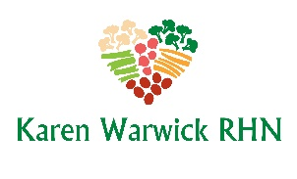
OIL FREE PESTO ON PASTA WITH STEAMED GREENS
Adding steamed vegetables really bulks up the serving size while adding healthy greens. My favorite is bok choy but you can use any other leafy greens you have on hand.
The Pesto is oil free but does contain nuts. The pesto recipe makes enough for two servings. So divide it up and freeze one serving or double the pasta and greens to serve two people.
​
Ingredients:
Oil-Free Pesto:
- 2 cups tightly packed basil​
- ½ cup walnuts or pine nuts
- 4 cloves garlic
- 1/3 cup lemon juice
- 2 Tbs. nutritional yeast

Pasta & Greens:
- ​1 cup cooked gluten-free brown rice pasta. (Or to lower the calories use zoodles or konjac noodles.)
- 2-3 cups bok choy, chopped
Method:
- ​ To make the pesto, add all ingredients to food processor and process until well combined. If it is too dry to combine, add a little water to thin it out.
- Cook the pasta as directed on the package or until al dente (10 minutes tops).
- Chop and lightly steam the bok choy.
- Drain the pasta, stir through the pesto and bok choy and serve in a bowl or on a plate.

