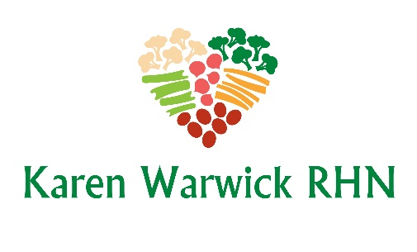
PUMPKIN PIE SQUARES
By Straight Up Food
I have slightly adapted this recipe. This is like eating pumpkin pie without the crust. So yummy and low fat and no sugar. The sweetness comes from the dates, so it is high in fiber and guilt free. Makes 16 squares.
Ingredients
- 11 Medjool dates, chopped
- 1 cup oat milk
- 1 tsp. vanilla extract or vanilla powder
- 1 ¼ cups rolled oats
- 2 tsps. pumpkin pie spice
- 1 can 100% pure pumpkin
Method
- Place the dates, oat milk and vanilla into a small bowl, and set aside for at least 15 minutes so the dates can soften.
- Preheat the oven to 375°F. Line an 8x8-inch baking pan with parchment paper or use silicon bakeware.
- Grind the oats into flour in a blender. Transfer to a large bowl and whisk with the pumpkin spice.
- Pour the dates, milk and vanilla into the blender and blend until smooth.
- Pour this mixture into the bowl of dry ingredients, and add the pumpkin. Mix the batter well until it is thick and smooth.
- Spoon the batter into the pan and spread evenly. Bake for 30 minutes. Let cool completely before serving (or chill overnight for firmer squares).

