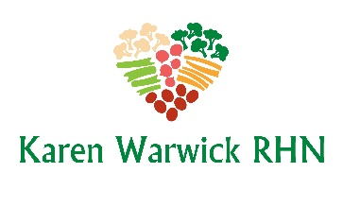
COMPLIANT GREEN GOODNESS SOUP
Forget chicken soup for a cold. This soup packs a Vitamin C punch, thanks to the combination of greens, red skin potatoes and frozen broccoli. And green lentils are filled with protein, fiber and folate, which supports red blood cell production and neurological function.
Ingredients:
- A little purified water for ‘frying’
- 1 Tbs. cumin
- 1 Tbs. curry powder
- 1 Tbs. dried basil
- 1 cup green lentils, rinsed
- 8 cloves garlic, minced or diced finely
- 6 cups unfiltered water or LOW SODIUM SOUP STOCK (RECIPES - Karen Warwick RHN)
- 3 red skin potatoes, diced in ½ inch cubes (or 8 nugget size)
- 4 cups frozen broccoli or 1 fresh broccoli finely chopped
- 8 kale leaves, chopped
- Pepper to taste
- Optional finishing: 1 Tbs. onion powder, 1 Tbs. garlic powder, 1 Tbs. apple cider vinegar and 1 tsp. kelp powder.

Method:
- Add a little water to a large pot and bring up to medium-low heat.
- Stir in the curry powder, cumin, and dried basil. Heat for about 1 minute, stirring frequently.
- Add the green lentils, garlic, and filtered water (or LOW SODIUM SOUP STOCK) to the pot and bring up to a low boil.
- After about 8 minutes, add the red skin potatoes to the pot. (You may want to add additional water here depending your preference, adding 1/2 cup at a time.)
- When the green lentils and red skin potatoes are soft (after 10-15 more minutes of cooking), add the frozen broccoli and kale.
- Cover and heat until the frozen broccoli is warm.
- Add more spice and herb as desired. Extra curry powder will give this soup an extra kick! Season to taste.

