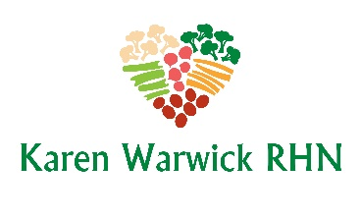
COMPLIANT MUNG BEAN AND KALE SOUP
What is a mung bean? When you buy bean spouts from a grocery store or get them in your Chinese food, that’s a mung bean spout. A mung bean is a small green bean that you can buy from most grocery stores.
These little beans are great for healing the gut. This particular recipe is from Dr. Axe’s Leaky Gut protocol. I have adapted it to make it a compliant plant-based option. This soup is healthful and flavorful. I hope you enjoy it as much as I do. This is a full pot and makes about 8 servings.
Ingredients:
- 1 small onion, chopped
- 5 garlic cloves, minced or finely chopped
- 1 cup mung beans, rinsed
- 1 tsp. turmeric
- 1 tsp. cumin
- 1 Tbs. dried coriander
- ½ tsp. pepper
- 6 cups filtered water or LOW SODIUM SOUP STOCK (RECIPES - Karen Warwick RHN)
- 2 cups kale, chopped
Method:
- In a soup pot, heat a little water over medium heat (4-6).
- Add the onion and cook for 5 minutes.
- Add the garlic and cook for 2-3 more minutes.
- Add the mung beans and spices and stir to mix well.
- Add the filtered water or LOW SODIUM SOUP STOCK.
- Cover and cook for 35-40 minutes or until tender. Stir occasionally, to make sure there is still liquid in the pot. If it gets too low add more filtered water.
- Once the beans are cooked through and soft, add the kale and cook for an additional 5 minutes until it is soft.
- Serve the soup and/or freeze it for leftovers as it freezes well.

