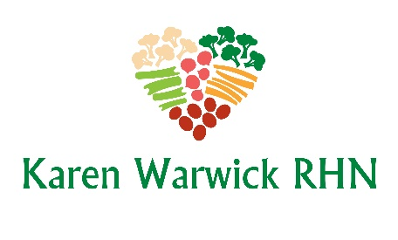
Wild Rice and Bean Salad
I got rid of all the fat and kept all the flavour. This recipe is great served cold for hot summer days. I also use it as a hot side dish or better yet used to stuff peppers and portobello mushrooms for a quick meal.
Ingredients:
- 1 cup mixed wild blend rice
- 1 cup veggie broth
- ¾ cup filtered water
- 1 onion, finely chopped
- 2-3 stalks of celery, chopped
- 1 Tbs. curry powder
- 2 tsp. paprika
Then…
- ½ can chickpeas, rinsed
- ½ can black beans, rinsed
- 3-4 green onions, chopped
- 2-3 Tbs. Braggs Liquid Soy Seasoning (or Low Sodium Tamari)
Method:
- Add rice, veggie broth, water, onion, celery, curry powder and paprika to a medium-sized pot. Bring to a boil, reduce heat and cover. Cook for 45 minutes (or check the cooking time on the rice you are using). Let cool.
- In a big bowl, add rice mixture, chickpeas, black beans, green onions and Braggs Soy Seasoning. Mix to combine and serve or store in fridge.

